Spatial Mapping of GBV Services and Priority Access Gaps in Balaka District

Purpose and Scope
Balaka District is one of the most service-constrained districts in the study, with the fewest mapped GBV service points and some of the lowest spatial coverage ratios across all five districts (Mzimba, Mchinji, Nsanje, Phalombe and Balaka). Survivors particularly those in remote TAs such as Chanthunya and Phalula face extended travel times, high transport costs, and limited access to specialised services such as courts, OSCs and legal aid.
Spatial analysis indicates that GBV services are thinly distributed and highly dependent on a few key facilities located along the main road corridor. Average travel times in Balaka’s TAs often exceed one hour (e.g., Chanthunya & Phalula 73 minutes), and remote areas experience substantial terrain, cost, and seasonal-access barriers. This policy brief provides a synthesis of GIS spatial analysis, TA-level population density mapping and facility-level referral and resolution data and actionable recommendations for improving survivor-centred access and reducing spatial inequity in Balaka District.
Spatial Profile of GBV Services in Mzimba
Balaka is characterised by a mix of moderate-to-high population density along the central transport corridor and sparser settlements in peripheral and upland areas:
- Balaka had only 11 mapped GBV service points, the lowest number among the five study districts.
  - TA Chanthunya: 5 facilities (a mix of CVSUs, community-based structures, police VSU and health facilities).
  - TA Phalula: 6 facilities (health clinic, PVSU, CVSU and community structures).
- Service distribution is thin and linear:
  - Most GBV providers (health, PVSU, CVSU, women’s forums) are aligned along the main Balaka–Liwonde transport axis.
  - Large interior and off-road villages in both TAs rely on distant service points or must travel directly to Balaka Boma for specialised support.
- Average travel time to the nearest GBV service in the modelling for Chanthunya and Phalula is 73 minutes, placing Balaka among the highest travel-time profiles in the study.
  - Households near the main road experience shorter, more predictable access.
  - Off-corridor, upland and scattered settlements often face >1 hour of travel per trip, particularly during the rainy season.
- Population density in Balaka is moderate, with denser clusters around trading centres and the main corridor and lower density in peripheral zones.
  - This means that a relatively small number of facilities shoulder large catchments along the corridor, while low-density but high-vulnerability communities at the edges are significantly disadvantaged.
- Transport cost bands in Balaka align with the broader study pattern:
  - Many survivors in Chanthunya and Phalula fall into the MWK 6,000–10,000 per trip range, with higher effective costs for multi-stage journeys (village → TA centre → Balaka Boma).
  - Repeated travel for health follow-up, police statements, and court appearances quickly becomes unaffordable for poor households.
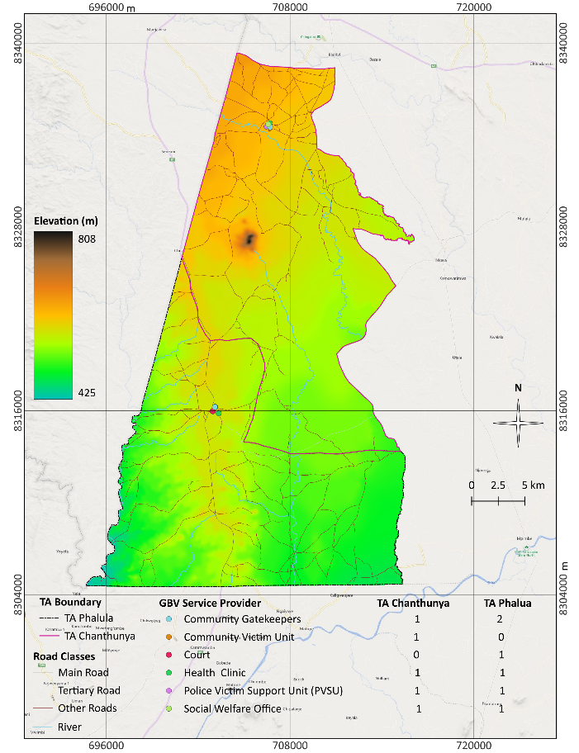
Figure 1: Distribution of GBV Service Providers in TAs Chanthunya & Phalula
Implication:
With only 11 facilities district-wide and long travel times across both TAs, Balaka is structurally vulnerable to service interruption and survivor attrition.

Key Accessibility Gaps and Systems Challenges
The combined spatial, referral and case-management data points to a GBV system that is present and active across the two TAs, but structurally uneven, costly to access, and weakest where survivors need it most at the level of justice and long-term protection. Five interlinked systems challenges stand out.
- Spatial inequity across and within TAs was pronounced, with GBV services concentrated in a small number of service providers while large peripheral areas remained underserved, resulting in access-driven under-reporting rather than true differences in GBV incidence.
- Long travel distances (20–30 km), extended travel times (73 minutes), and high transport costs (MWK 6,000–10,000 per trip) acted as structural filters that disproportionately excluded poor, rural and remote survivors particularly in far-remote locations from accessing GBV services.
- While counselling and basic support were widely available, specialised GBV services including forensic care, legal aid and OSCs were sparse and district-based, and the justice system remained the weakest link, with magistrate courts resolving only 25% of cases and lacking criminal jurisdiction at 2nd/3rd grade magistrate level.
- Referral chains exhibited a steep attrition curve, where most cases originated and were resolved at community, health and police levels, but survivor engagement dropped sharply as cases moved toward the justice system due to distance, repeated travel requirements, costs and weak feedback loops.
- GBV information systems were fragmented across paper and digital tools, lacked unique case identifiers, applied inconsistent definitions of “case” and “resolved,” and suffered from missing disaggregation, resulting in unreliable totals, untraceable survivor pathways and limited capacity for accountability or learning.
- Survivor outcomes were shaped by interconnected location constraints determining physical access, income determining ability to follow through, service type determining case trajectory, and weak data systems obscuring gaps, highlighting the need for simultaneous action on spatial equity, affordability, service depth, referral linkages and data integration.
- Even before considering communication, attitudinal or financial barriers, around one in three GBV service points explicitly reported that their physical infrastructure is not accessible to persons with disabilities, and only about half reported meeting basic accessibility standards (e.g. ramps, wide entrances, accessible toilets).

Policy Recommendations
Policy Option 1: Mobile GBV Justice and Protection Services in Chanthunya and Phalula
Deploy mobile court and mobile PVSU/legal outreach teams on a scheduled basis to high-burden but remote zones in both TAs. These teams would provide statement-taking, basic legal counselling, case follow-up and coordinated sessions with police and social welfare closer to survivors’ homes.
Advantages: Reduces long travel time, encourages early reporting, increases likelihood of main cases reaching the justice system.
Equity impact: Very high for remote, low-income and female-headed households.
Policy Option 2: Establish a Sustainable Survivor Support Fund (SSF) and Accompaniment Mechanism
With long travel times (73 minutes) and high transport costs common in Chanthunya and Phalula, Balaka District requires a sustainable Survivor Support Fund (SSF) to mitigate severe economic barriers to GBV service access. The SSF should pool district contributions, donor seed support, private-sector CSR funds and community-driven IGAs, ensuring long-term viability. Structured transport vouchers and community-based accompaniment would reduce dropout during referrals and court proceedings especially critical in a district with only 14 GBV facilities and high dependence on the Balaka Boma service hub. A sustainably financed SSF would significantly improve survivor retention across the referral chain.
Advantages: Reduces financial barriers; increases court case follow-through.
Equity: High positive impact on the poorest households.
Policy Option 3: Co-design upgrading of Corridor-Based High-Volume Facilities
Facilities along Balaka’s main transport corridor particularly those in Chanthunya and Phalula handle the district’s largest GBV caseloads despite being few in number. Strengthening these high-volume sites by improving counselling rooms, ensuring privacy and survivor-friendly spaces, and upgrading medico-legal documentation capacity would significantly enhance service quality and reduce unnecessary referrals to Balaka Boma, easing the burden on survivors who already travel long distances at high cost.
Co-design upgrades with Organisations of Persons with Disabilities (OPDs) at district level to test access routes, advise on practical modifications, and validate whether reported “Yes” responses on accessibility reflect real, user-experienced access, not just provider perception.
Set minimum accessibility standards or a basic package for GBV service points (ramp or gently sloped entrance, firm pathways, accessible latrine, clear signage) that all GBV service providers should progressively meet.
Advantages: Builds on existing strong hubs; improves efficiency and quality.
Feasibility: High.
Equity: Benefits densely populated areas.
Policy Option 4: Institutionalising GIS for Planning and Resource Allocation
Annual GIS-based audits of service coverage, population density, travel times and TA-level gaps would inform district GBV planning and budgeting.
Advantages: Enhances evidence-based prioritisation; prevents spatial neglect.
Feasibility: High with partner support.

Methodology
Policy options were derived from spatial accessibility modelling (travel time surfaces, road networks, elevation) and TA-level population density analysis. Facility-level referral and resolution data (2022–2025) were triangulated with key informant consultations with police, health workers, CVUs, and district officers. Evidence quality was assessed through data completeness checks and plausibility reviews.

Further Important Considerations
Because of data-quality limitations (inconsistent definitions, outliers, missing values), the figures in this study were best treated as operational estimates rather than precise surveillance statistics. This implied that the rollout of recommendations should be coupled with an explicit monitoring and learning agenda: annual updates to GIS layers and dashboards, routine data-quality checks, and periodic sense-making sessions at district level to review patterns (e.g. travel times, referral completion, court progression) and adjust interventions accordingly. Over time, this iterative use of data could be more transformative than any single investment in infrastructure or training.

Acknowledgements
Prepared in collaboration with the Balaka District Gender Office, Social Welfare Office, Health Office, MICGBV partners, and frontline GBV service providers.

